Discover Dubai with INTRO TRAVELS INDIA
Dubai is one of the most luxurious and exciting travel destinations in the world. Located in the United Arab Emirates, Dubai is famous for its futuristic skyline, luxury shopping, desert adventures, stunning beaches, world-class attractions, and vibrant nightlife. Whether you are planning a honeymoon, family vacation, solo trip, or group tour, Dubai offers unforgettable experiences for every traveler.

Why Visit Dubai?
- Home to the world’s tallest building
- Luxury hotels & beach resorts
- Amazing desert safari experiences
- World-famous shopping malls
- Safe and modern city
- Family-friendly attractions
- Adventure activities & nightlife
- Perfect destination for luxury holidays

Top Tourist Attractions in Dubai
1. Burj Khalifa
The tallest building in the world at 828 meters.
Highlights:
- Observation decks on the 124th & 148th floors
- Spectacular city skyline views
- Dubai Fountain Show
- Luxury dining experiences
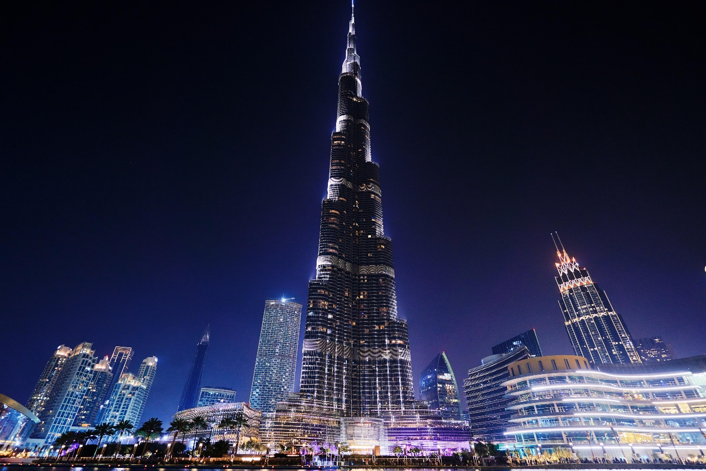
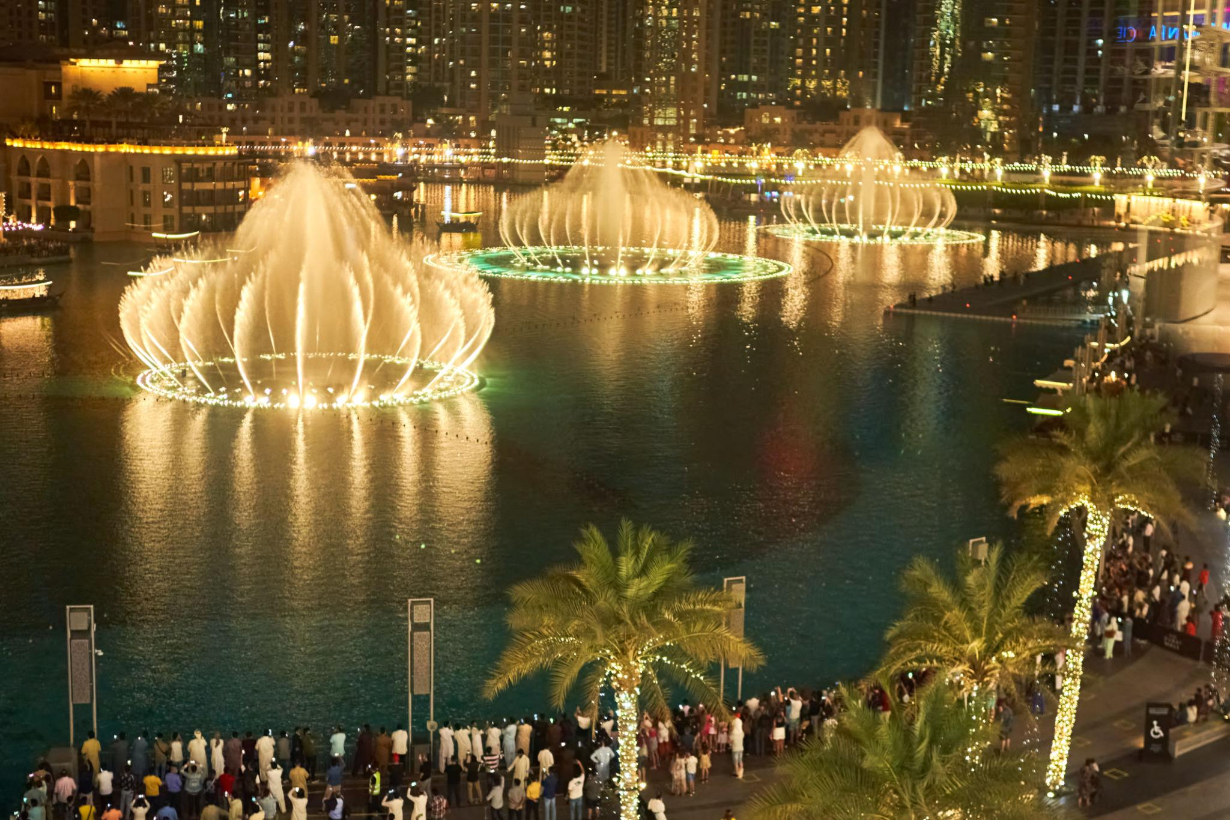
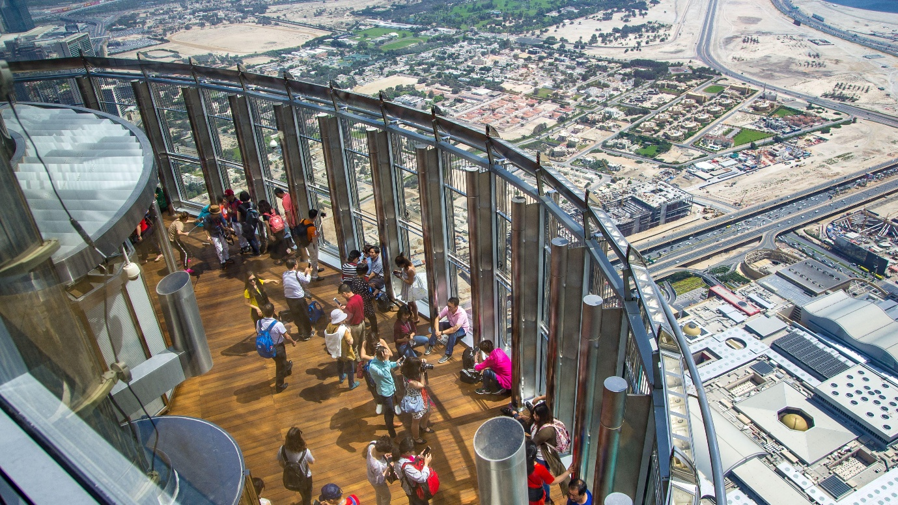
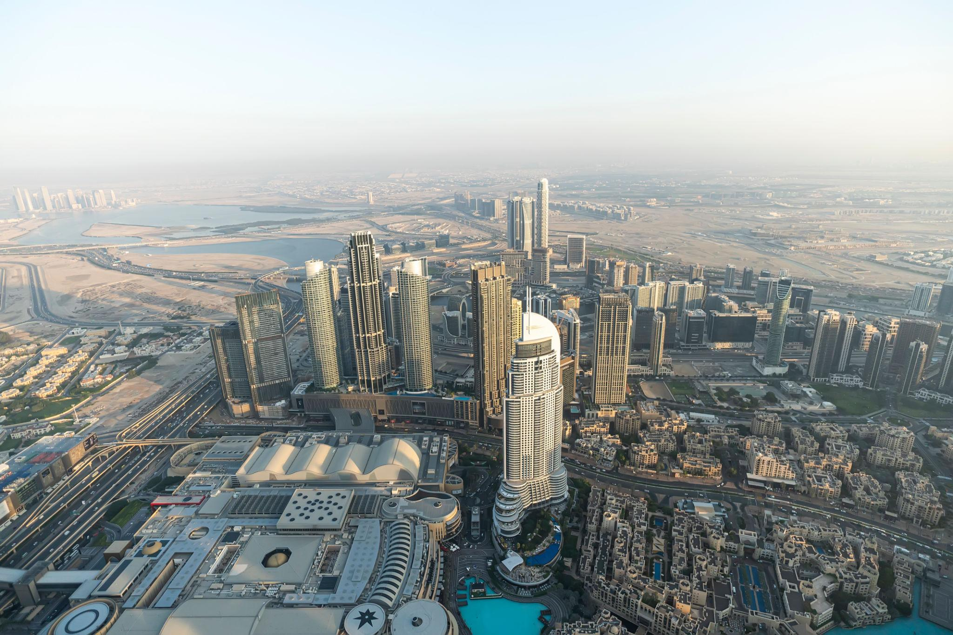
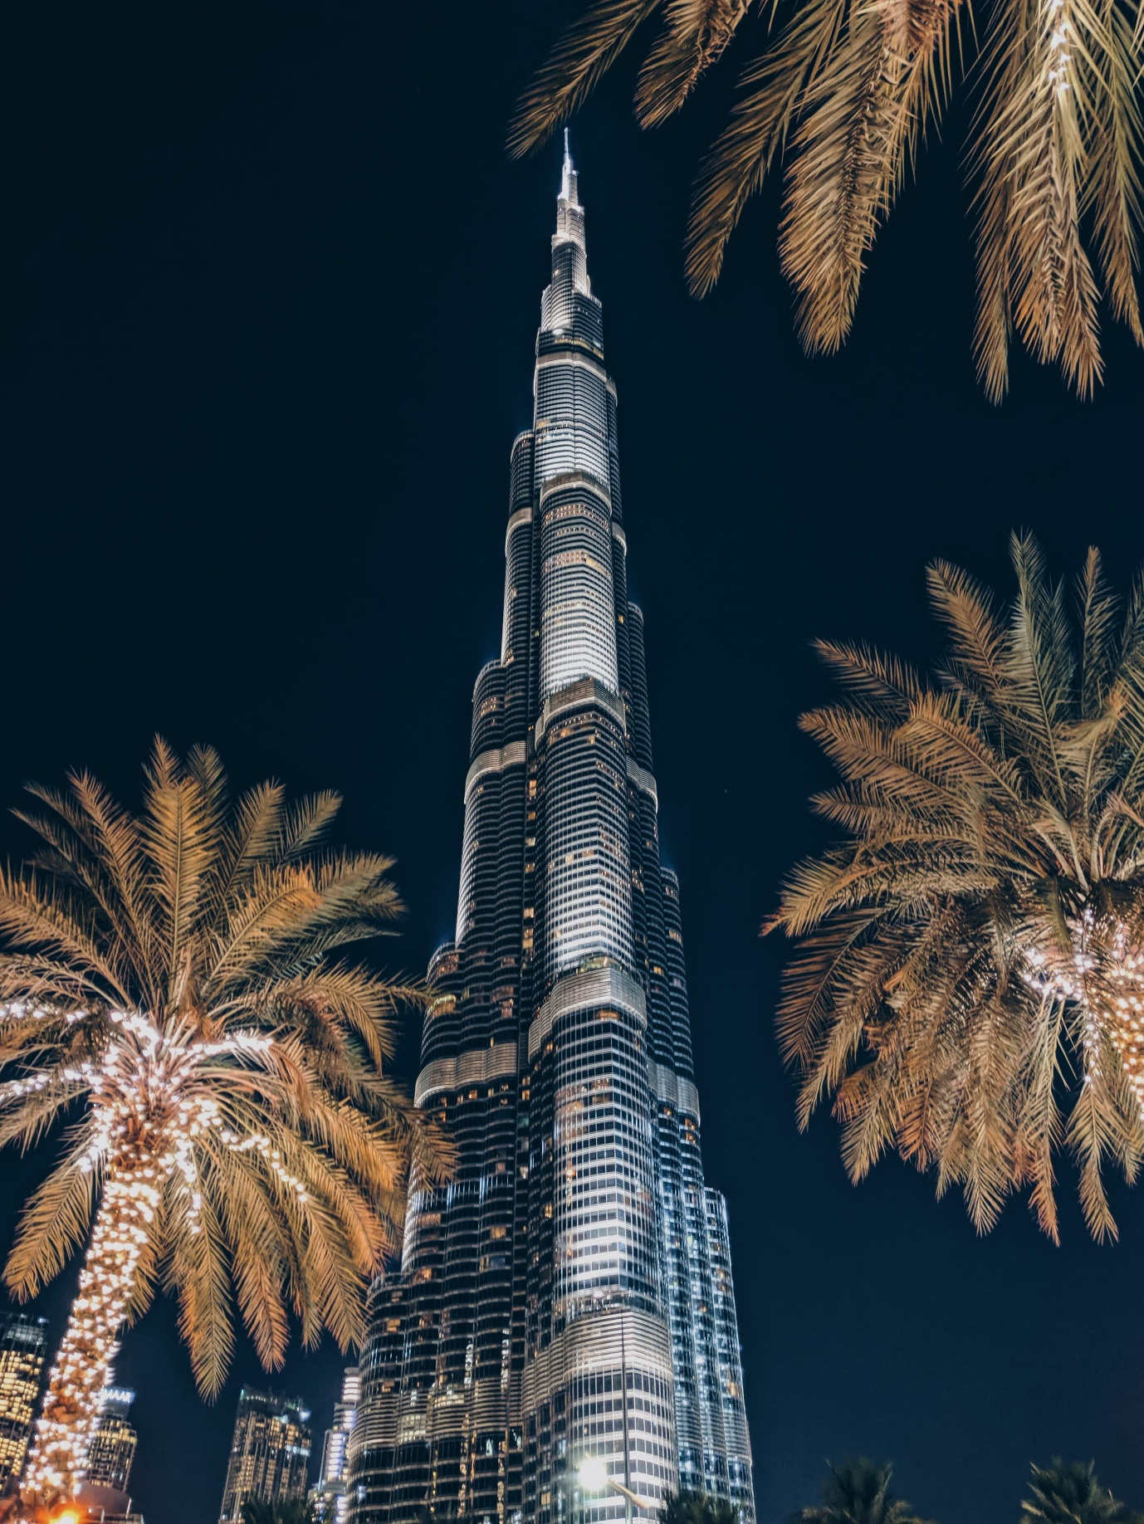
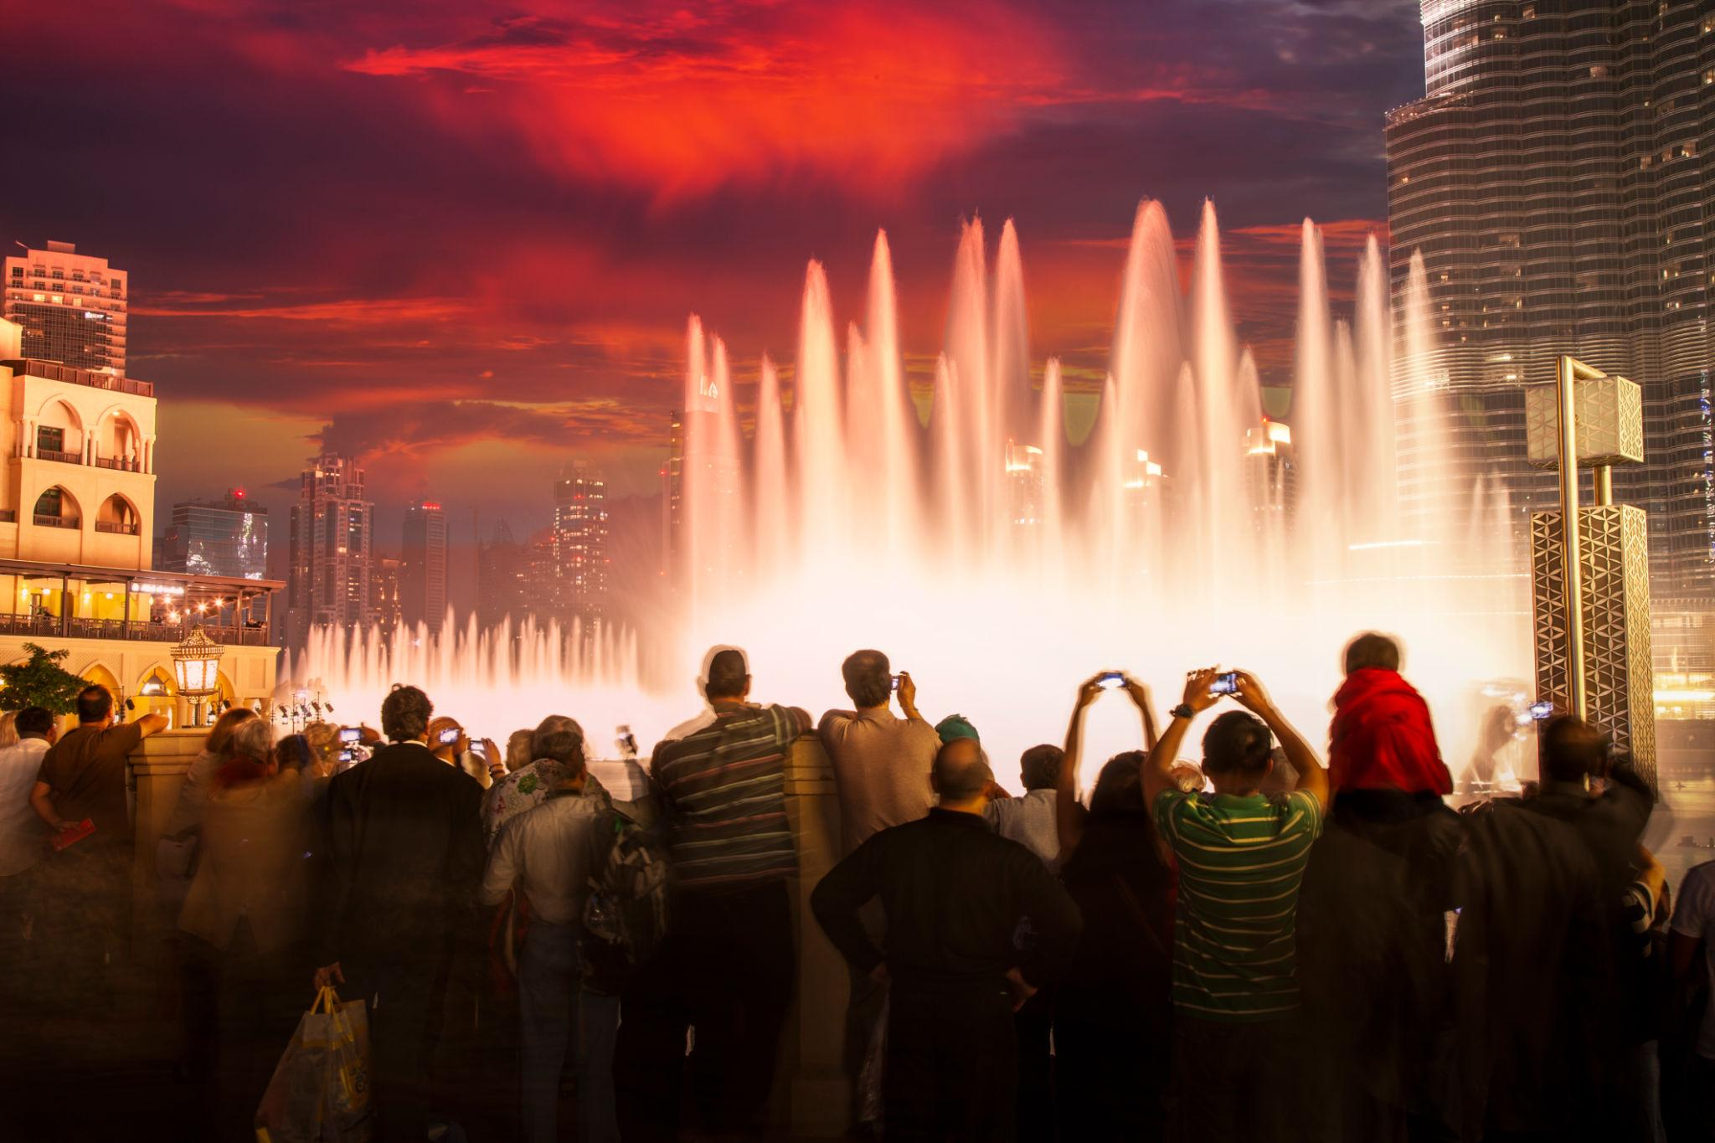

2. Palm Jumeirah
A world-famous man-made island shaped like a palm tree.
Known for:
- Luxury beach resorts
- Private villas
- Beach clubs
- Water sports
- Atlantis Aquaventure Waterpark
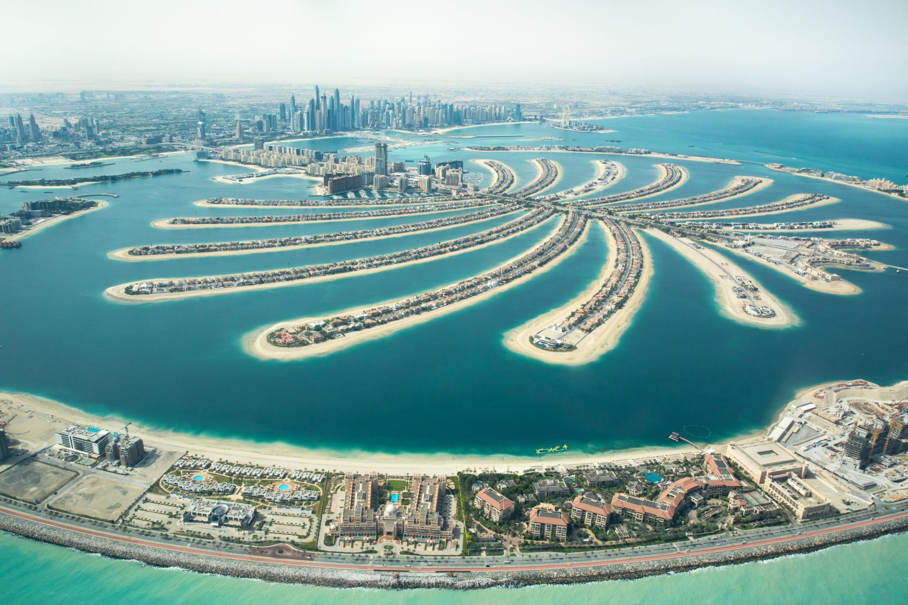

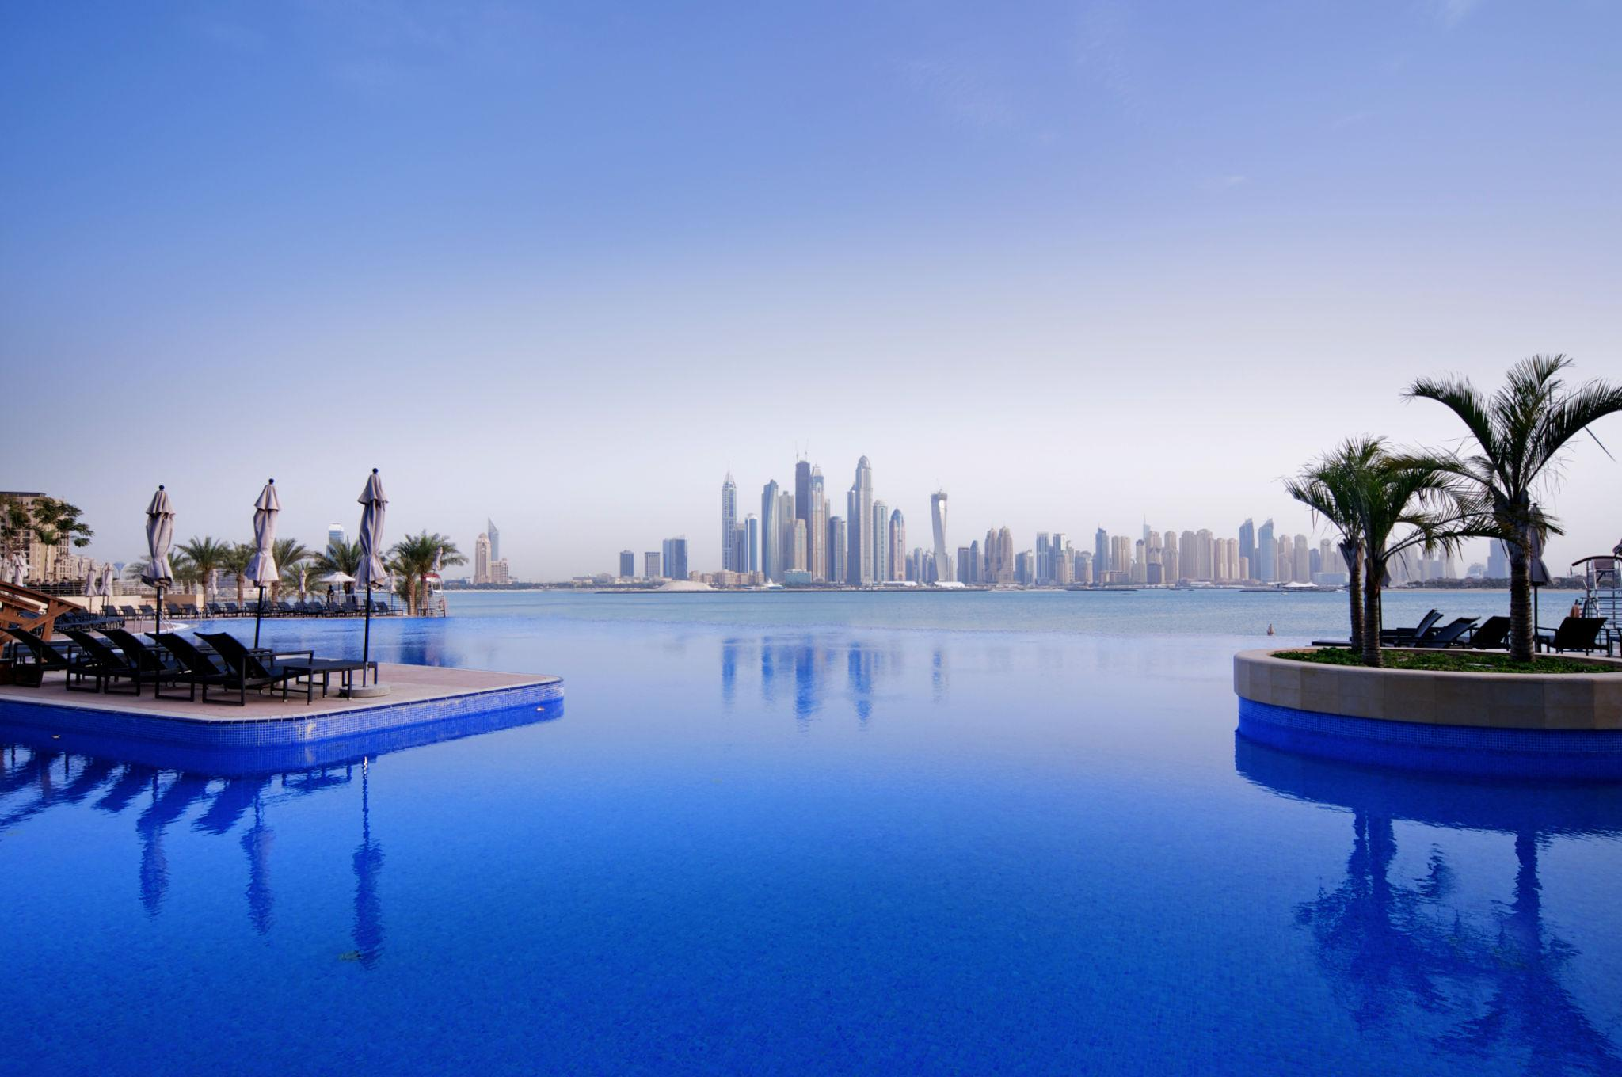
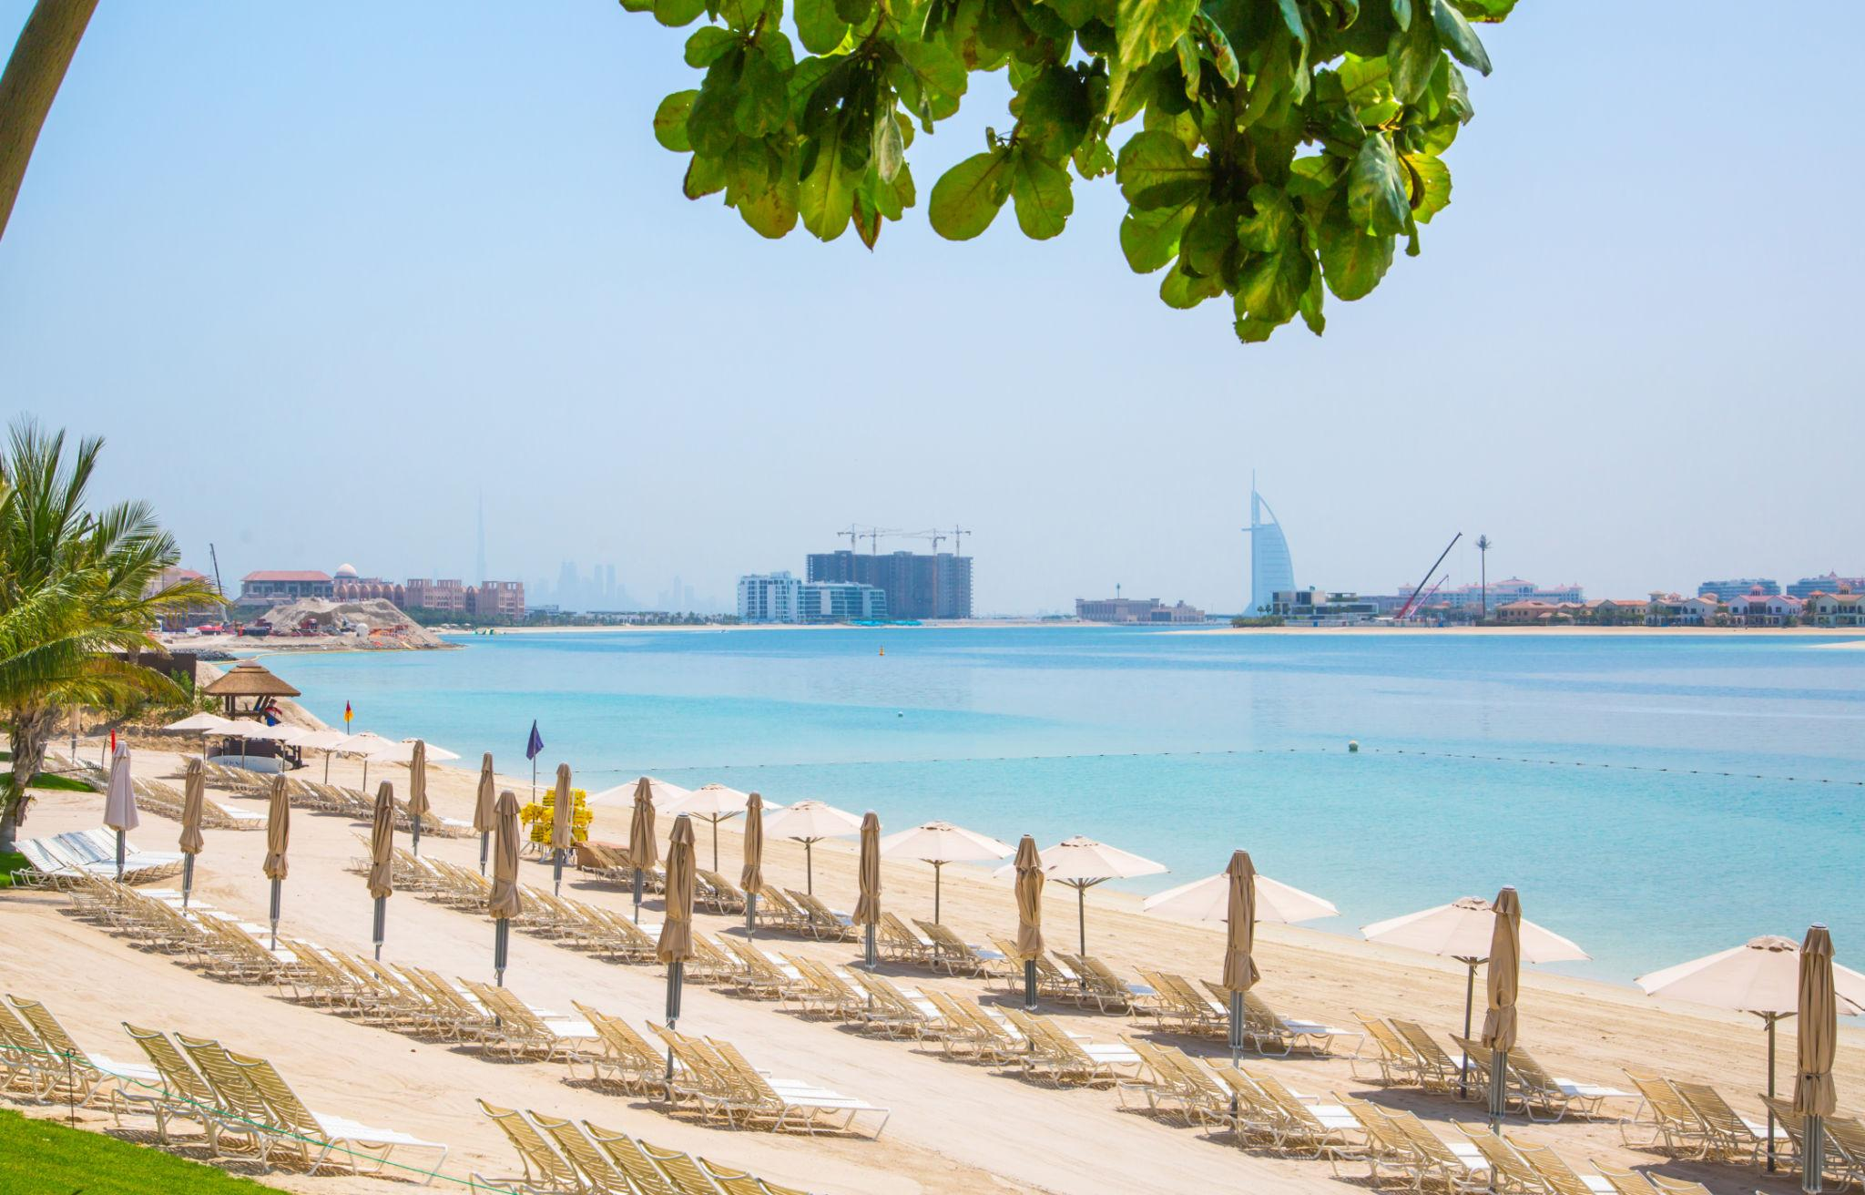
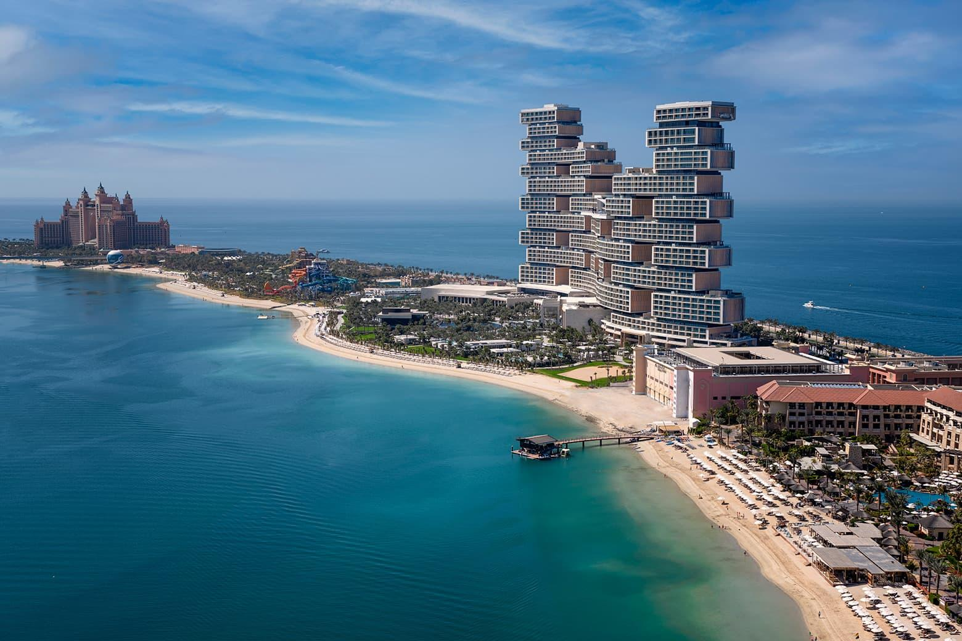
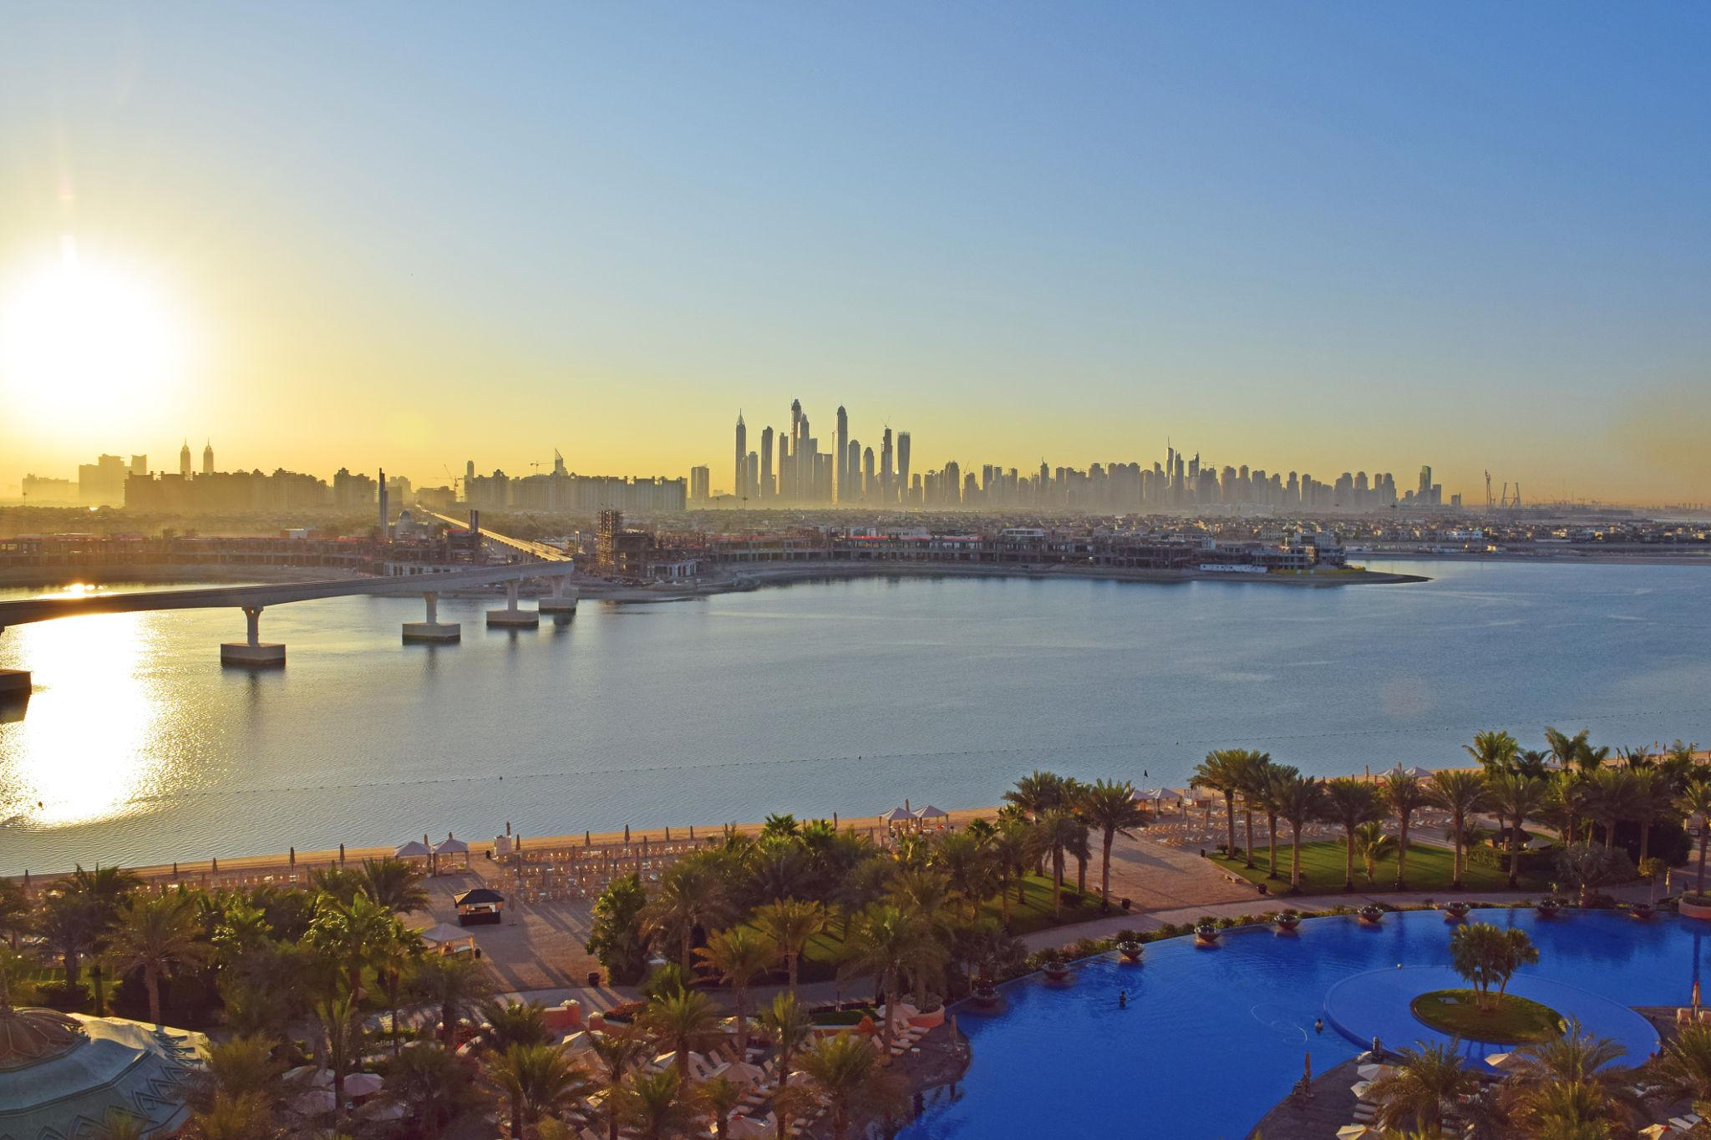

3. Dubai Mall
One of the largest shopping malls in the world.
Top attractions inside:
- Dubai Aquarium
- VR Park
- Ice Rink
- Luxury shopping brands
- Restaurants & cafés

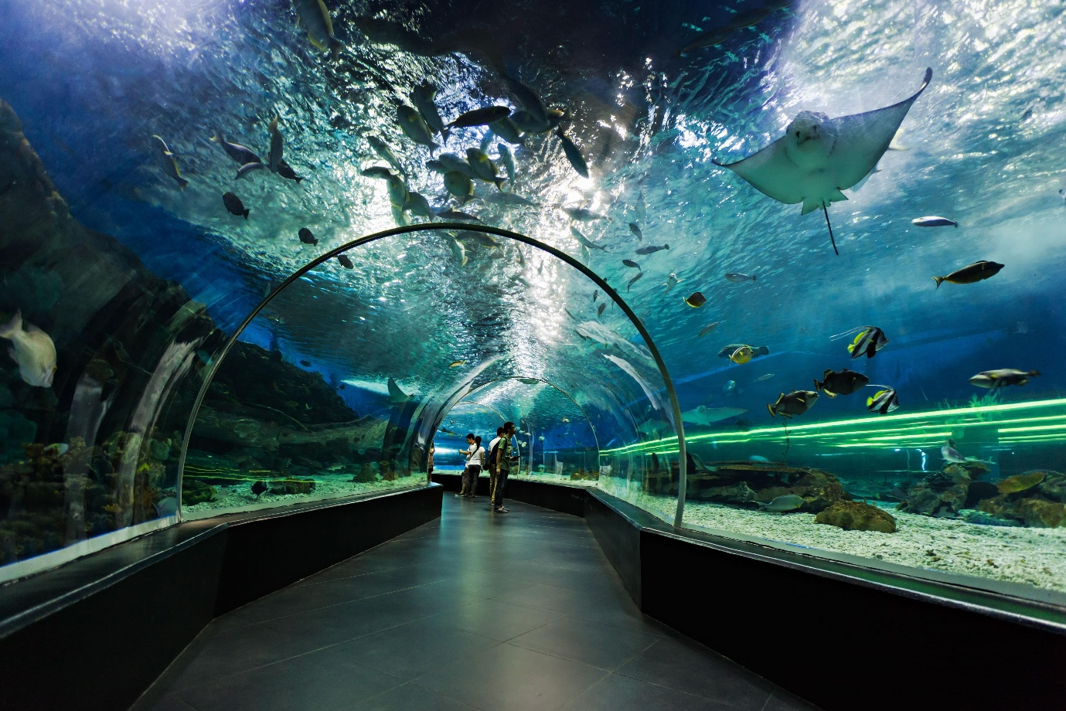
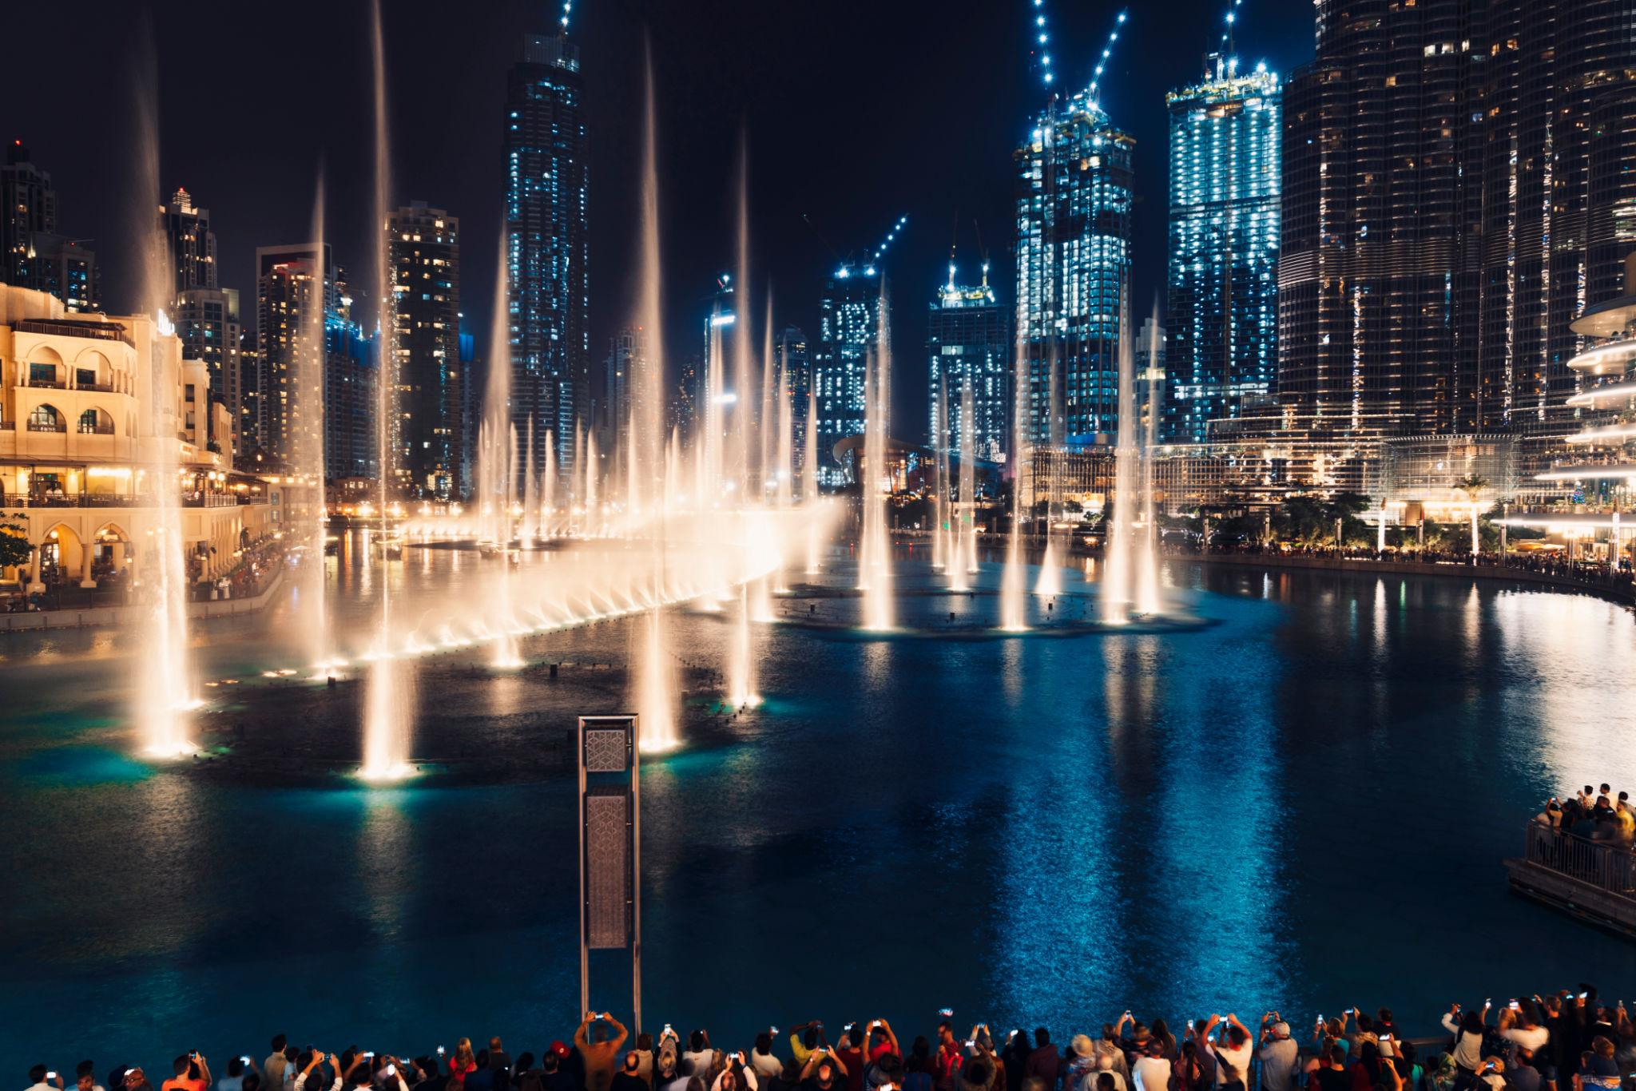
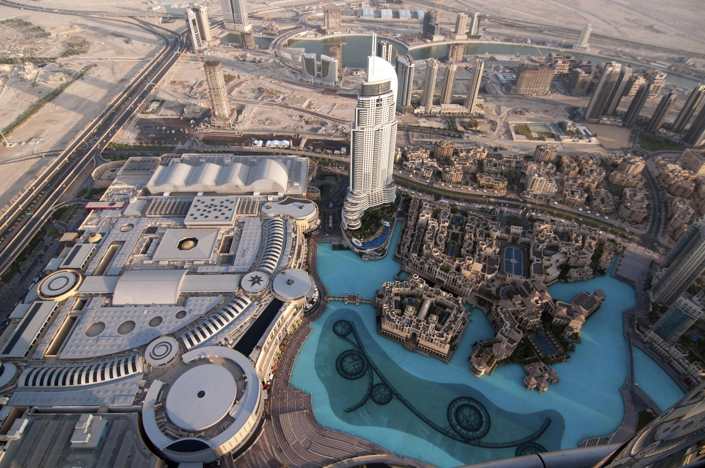



4. Dubai Desert Safari 🏜️
The most popular activity in Dubai.
Includes:
- Dune bashing
- Camel rides
- Sandboarding
- BBQ dinner
- Belly dance performances
- Traditional Arabic camp

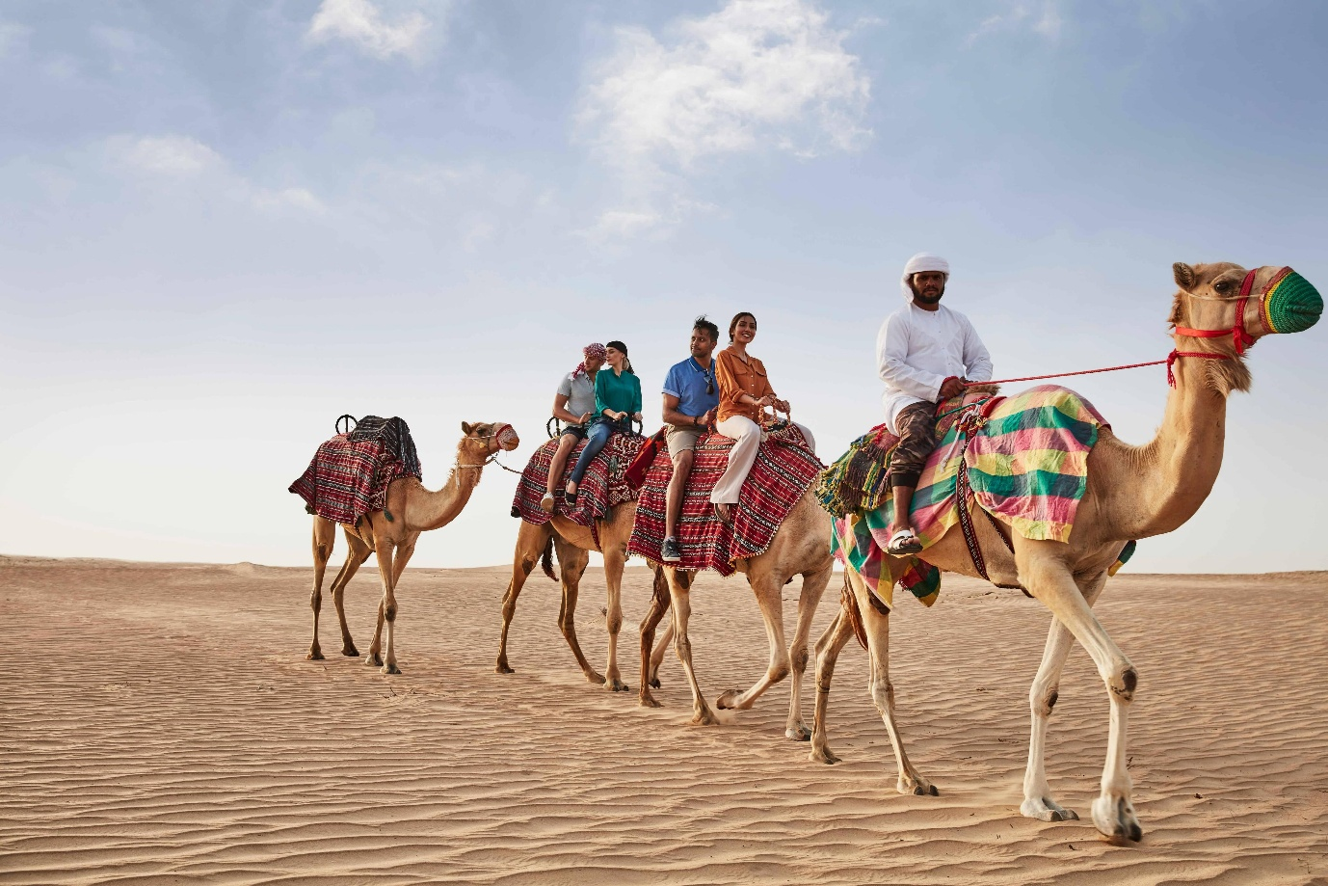
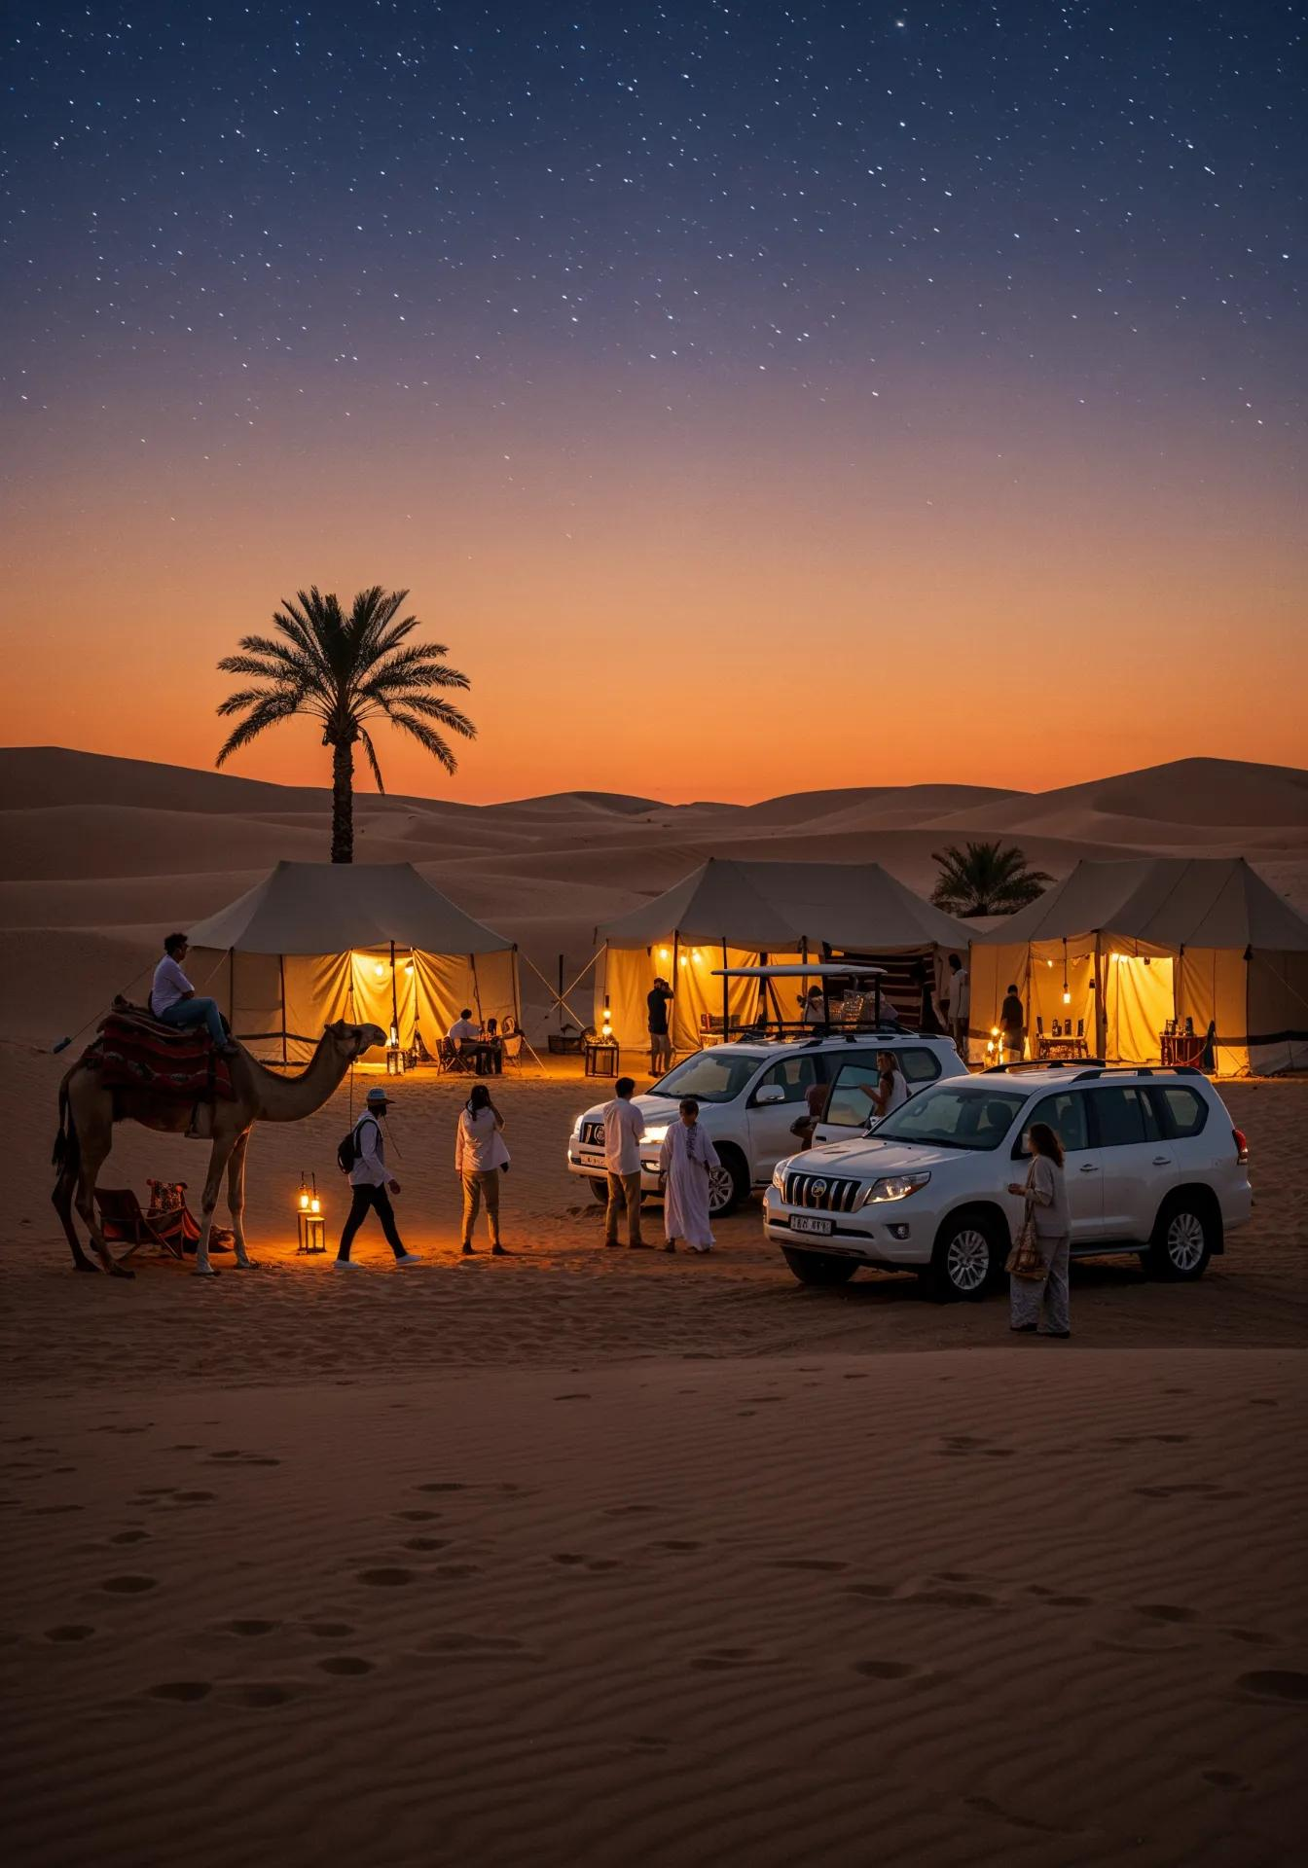
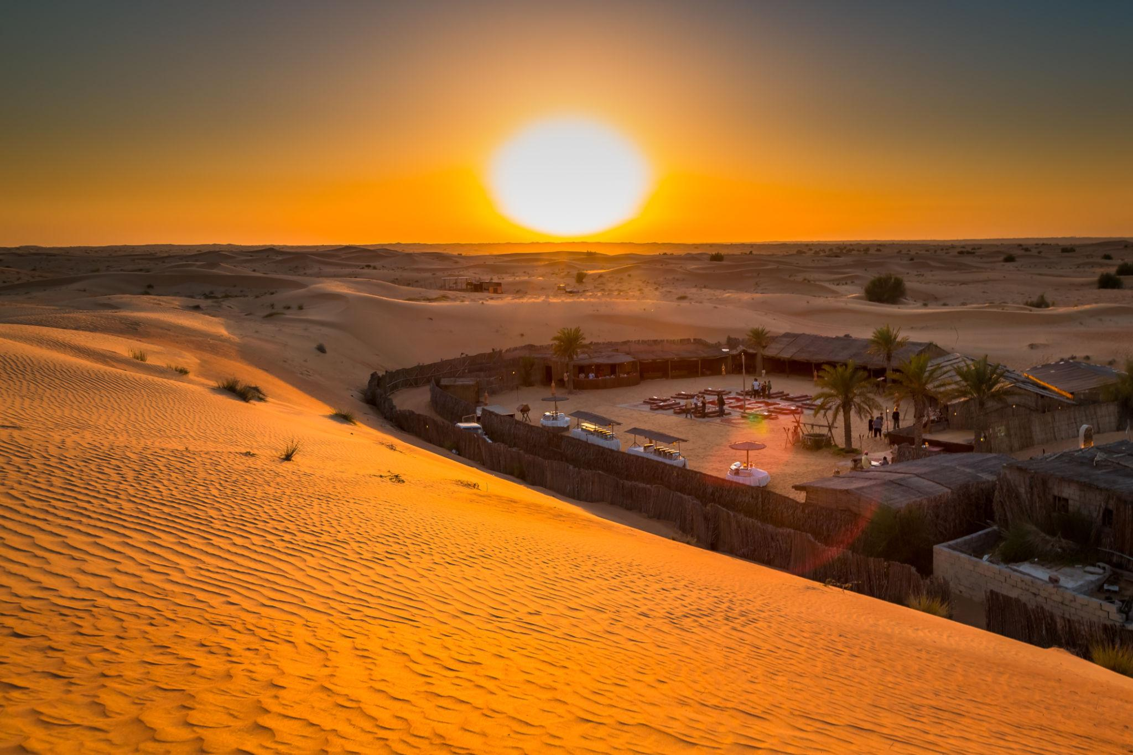
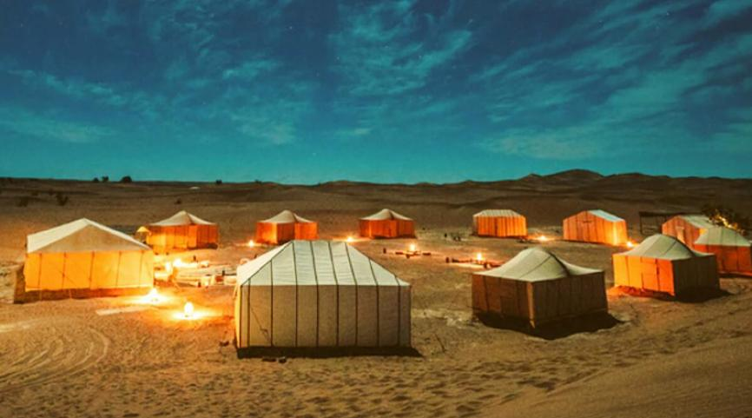




5. Dubai Marina
A beautiful waterfront destination with luxury yachts, skyscrapers, and nightlife.
Best experiences:
- Marina dinner cruise
- Yacht tours
- Fine dining
- Evening walk along Marina Walk
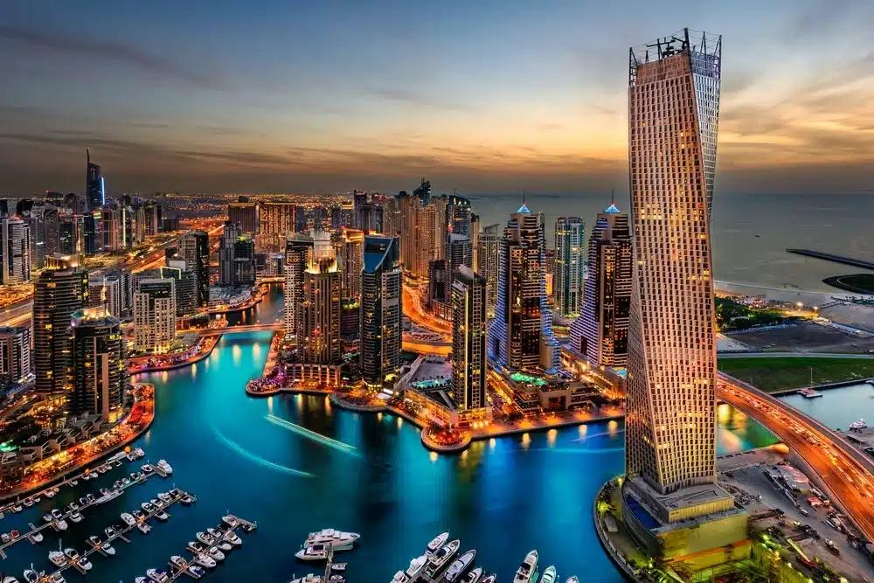
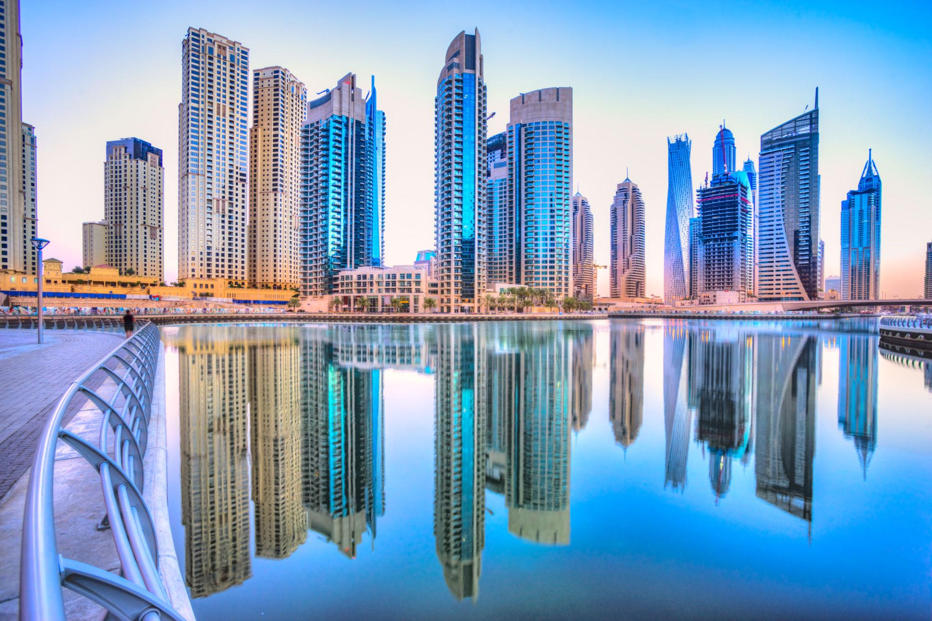
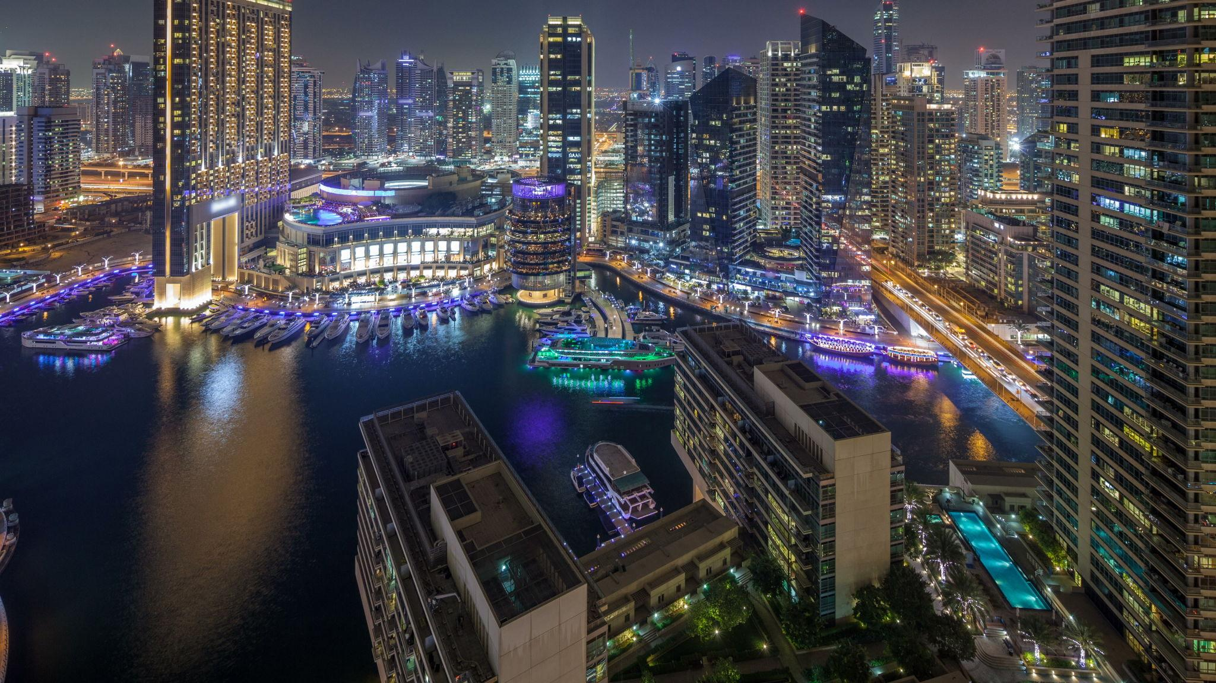
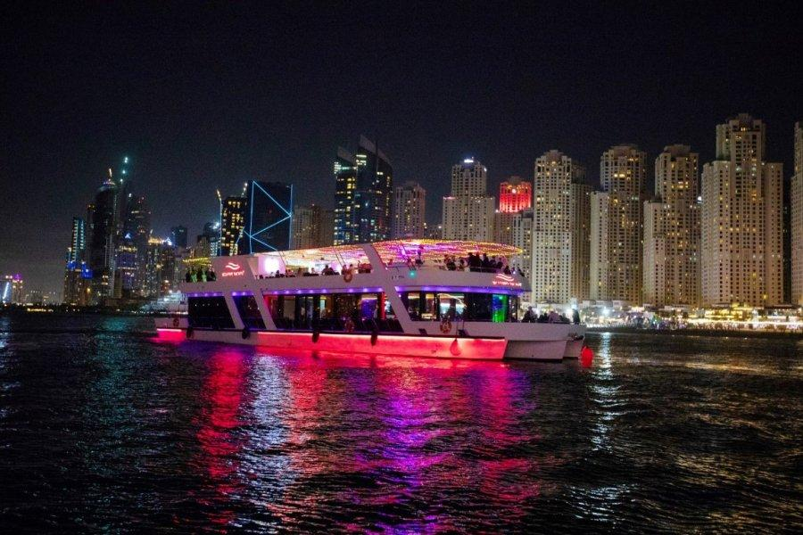
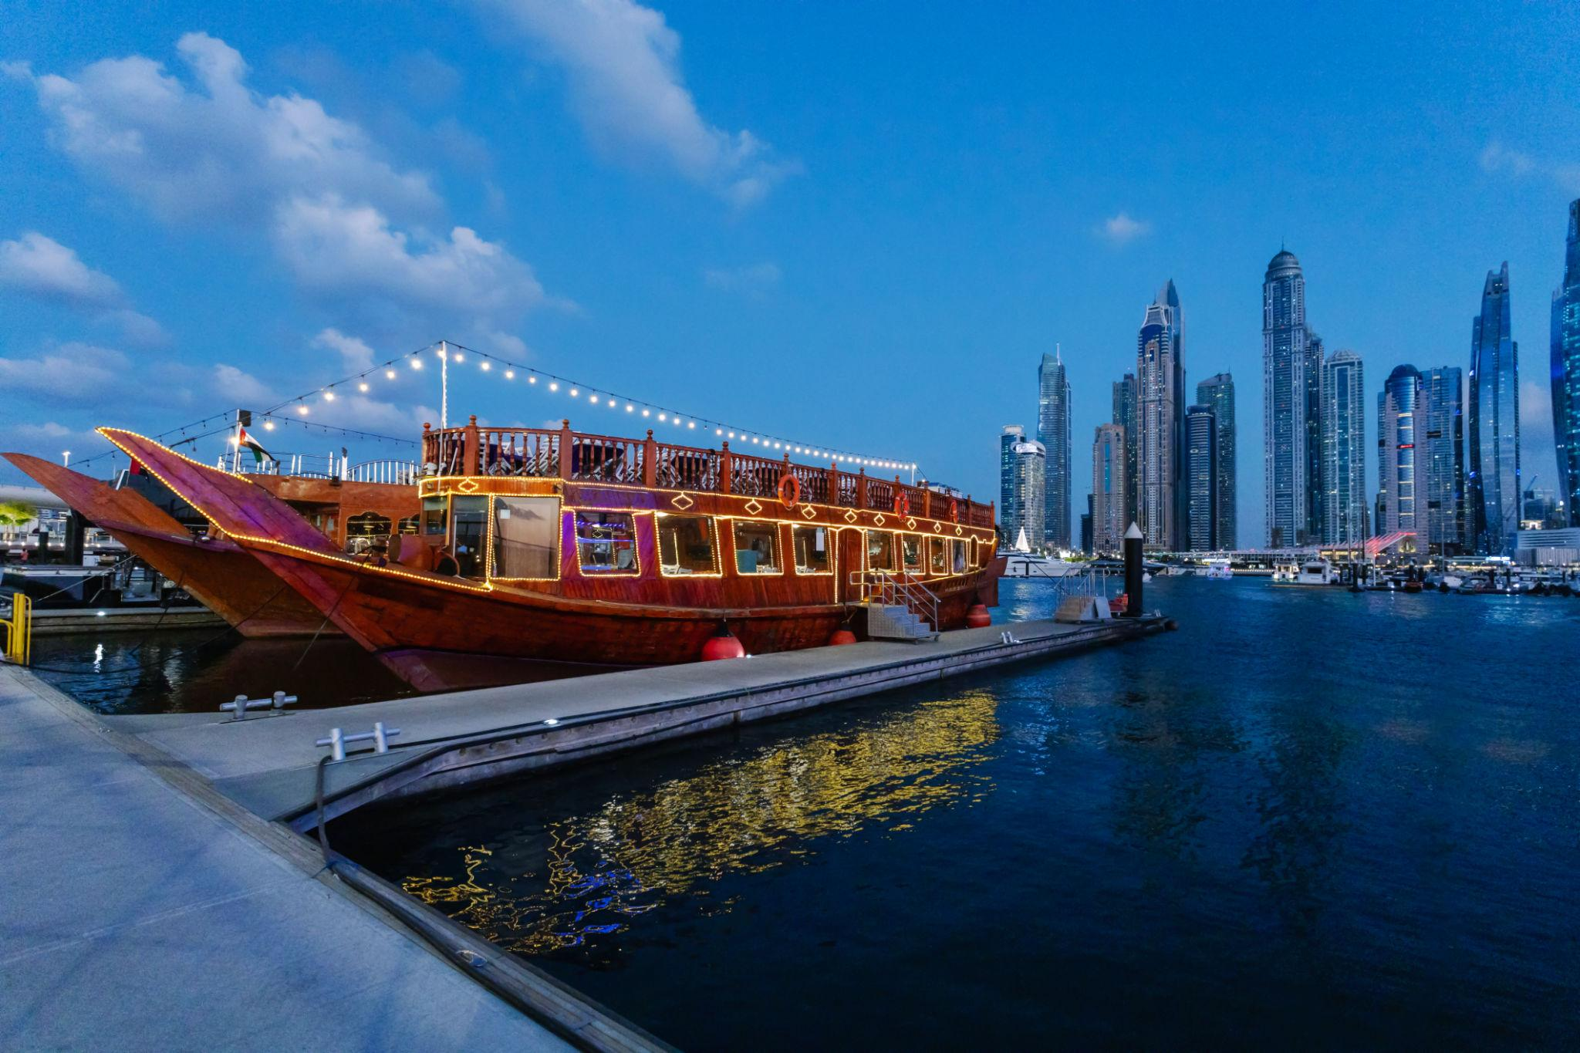

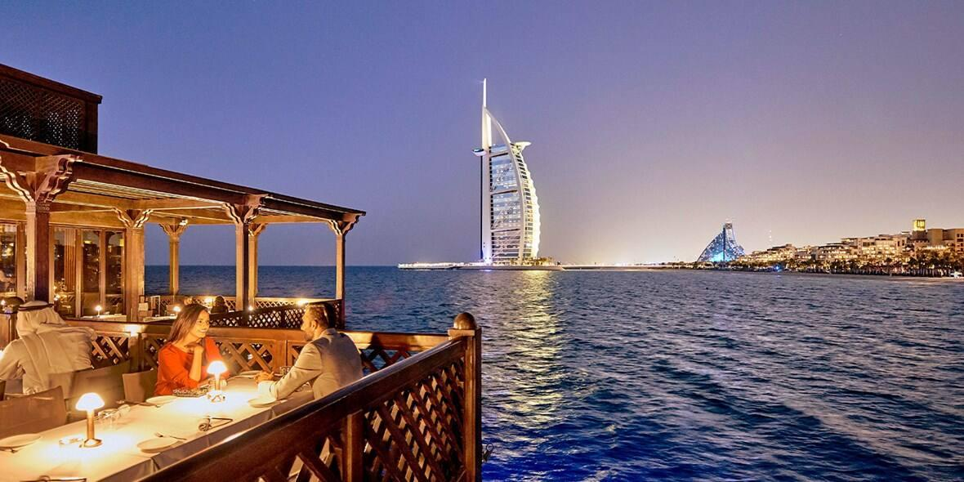

6. Museum of the Future
One of Dubai’s newest and most futuristic attractions.
Features:
- Artificial intelligence exhibits
- Space exploration concepts
- Future technology experiences
- Interactive science displays
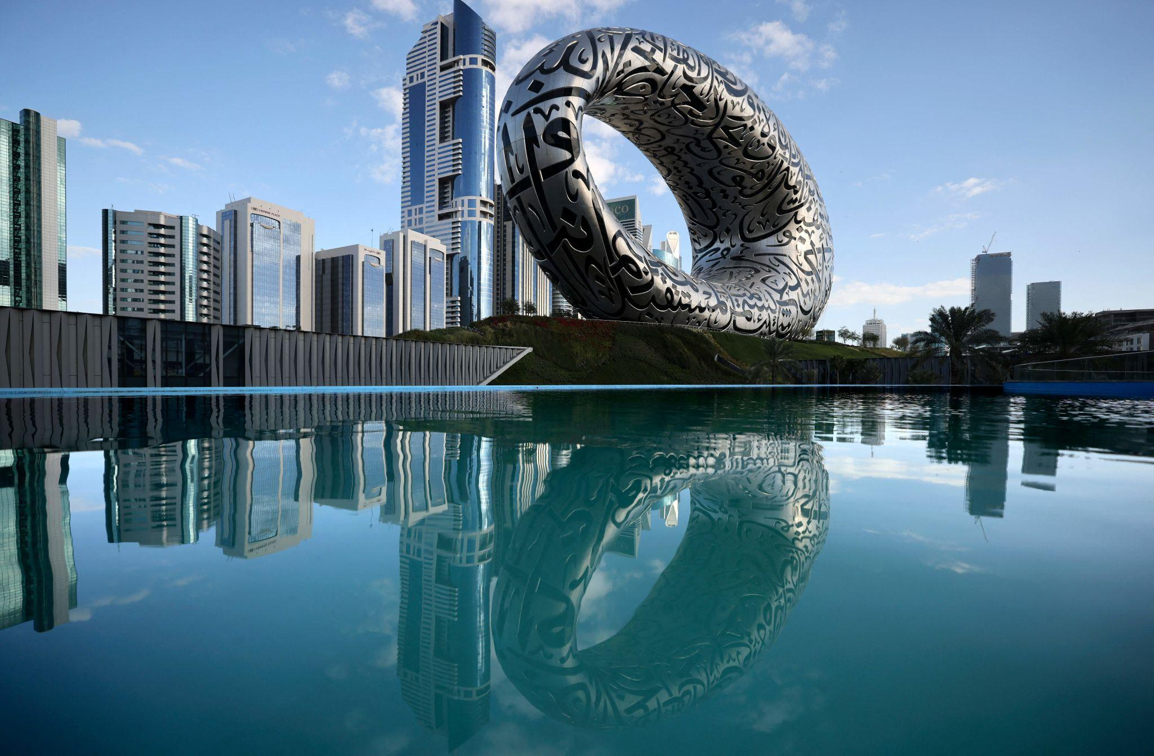
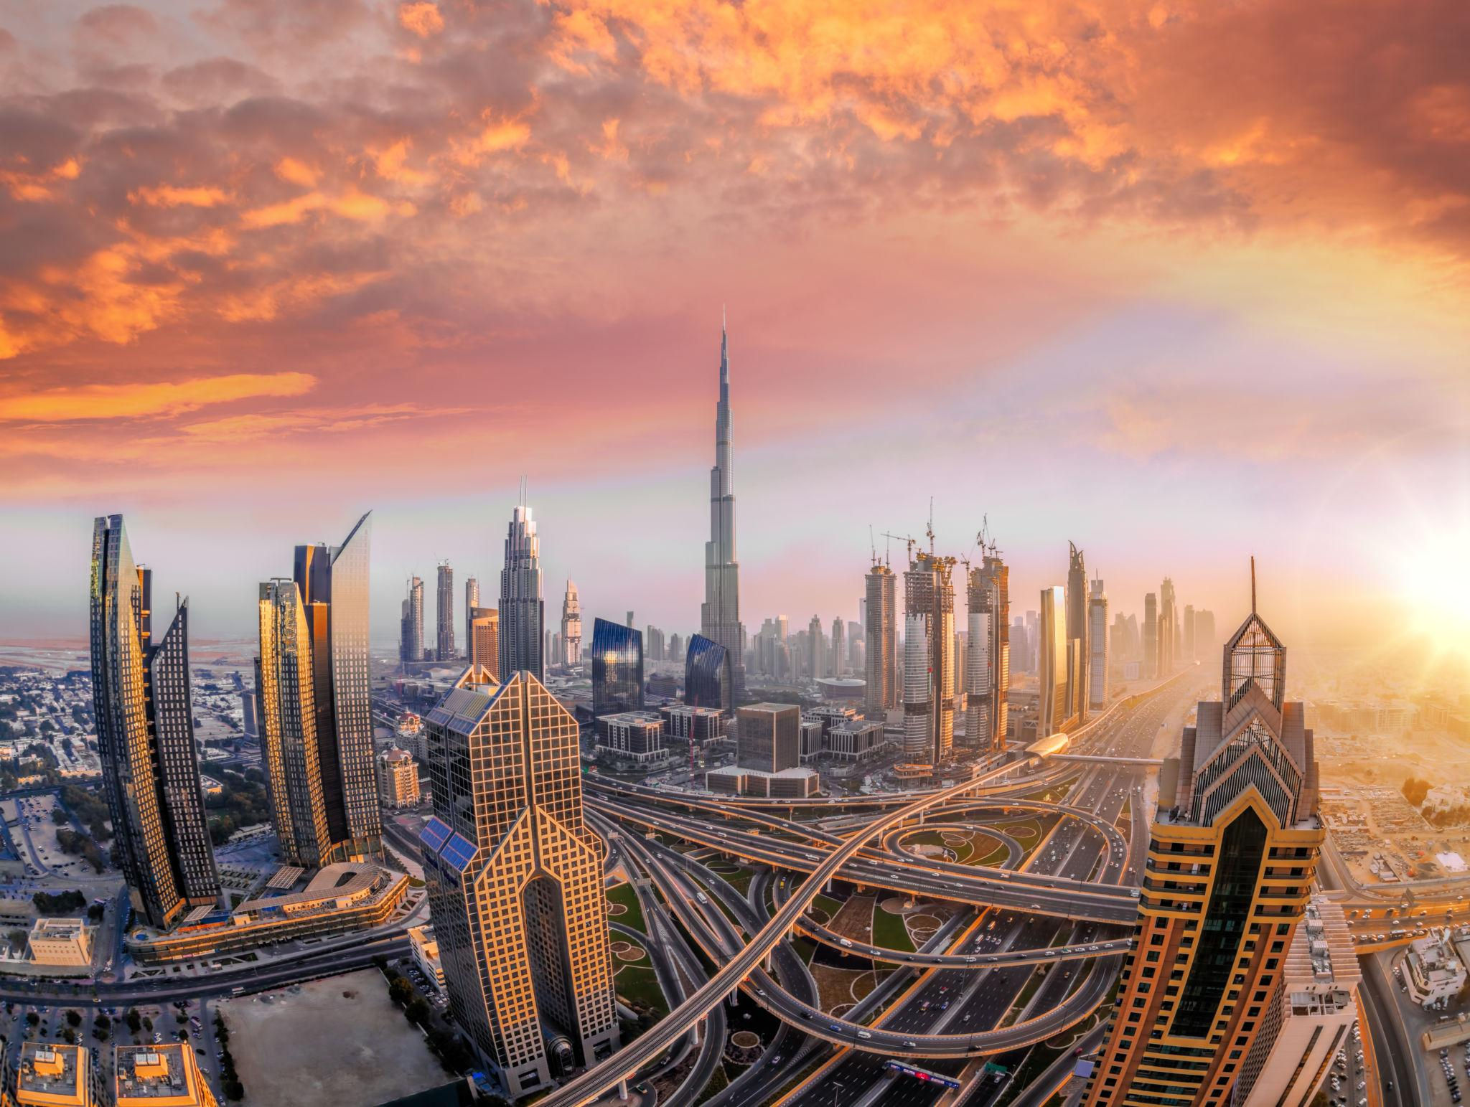

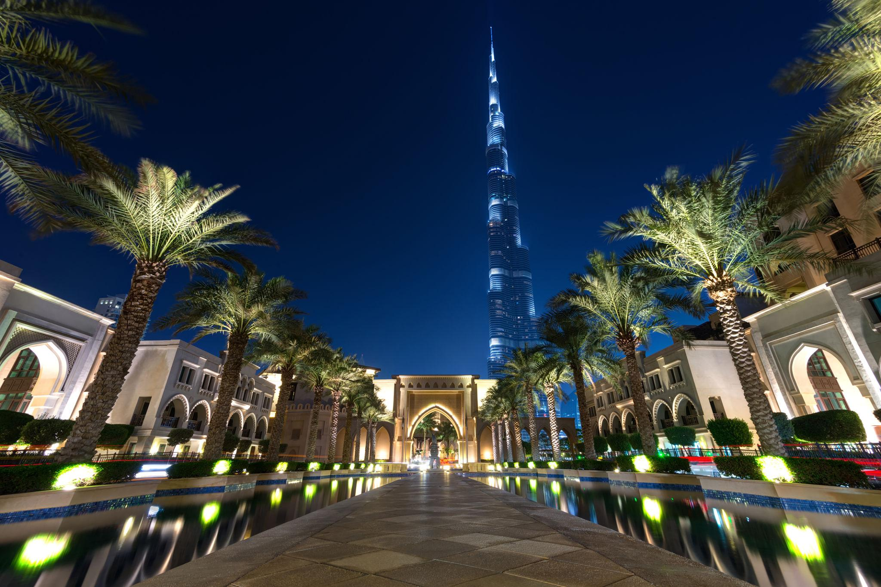
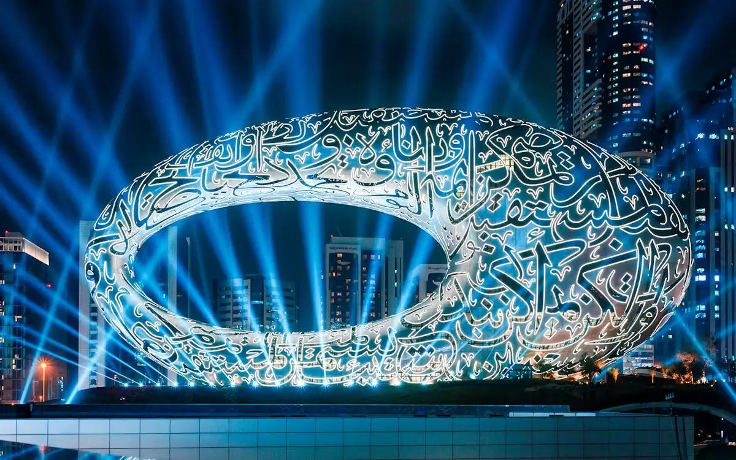


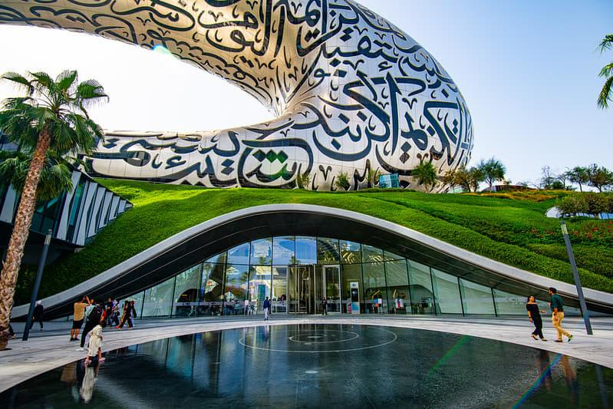

Best Things to Do in Dubai
- Visit Burj Khalifa
- Explore Dubai Mall
- Enjoy Desert Safari
- Take a Dhow Cruise Dinner
- Relax at Jumeirah Beach
- Visit Global Village
- Try Skydiving over Palm Jumeirah
- Enjoy Luxury Yacht Tours
- Visit Miracle Garden
- Explore Old Dubai & Gold Souk

Best Time to Visit Dubai
Season | Months | Weather
Winter Season | November – March | Pleasant & best for sightseeing
Summer Season | April – October | Very hot but cheaper hotels
The best months to visit are December, January, and February.

Dubai Visa for Indians 🇮🇳
Indian travelers generally need:
- Passport valid for 6 months
- UAE tourist visa
- Return flight tickets
- Hotel bookings
- Travel insurance
Some Indian passport holders with valid US, UK, or Schengen visas may be eligible for visa-on-arrival facilities.

Famous Foods to Try in Dubai 🍴
- Shawarma
- Arabic Mezze
- Luqaimat
- Mixed Grill Platters
- Kunafa
- Al Harees


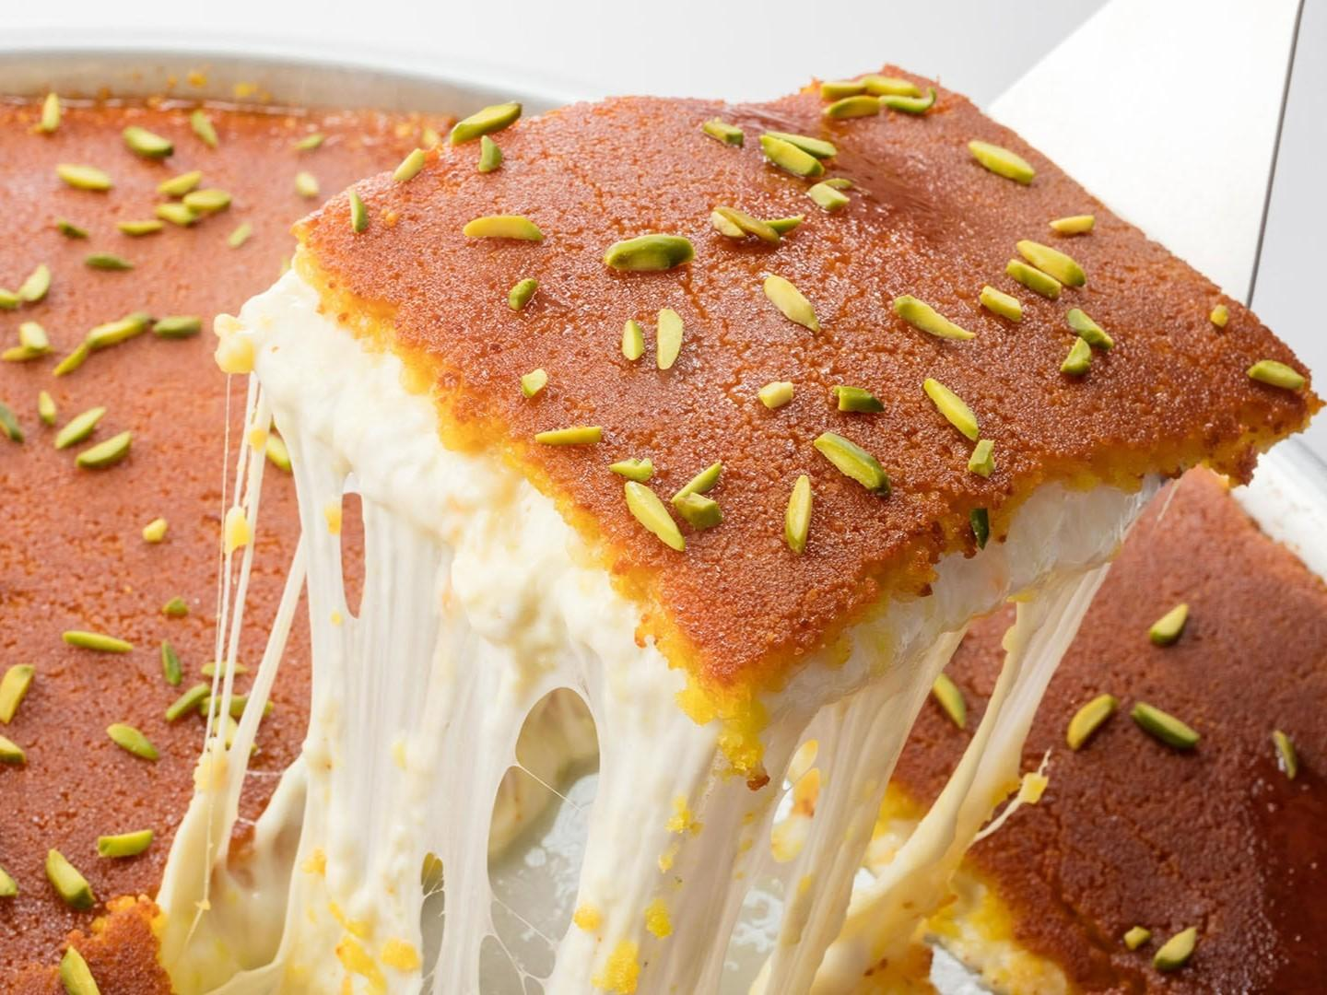




Luxury Experiences in Dubai ✨
- Helicopter ride over Dubai skyline
- Private yacht cruise
- Fine dining at Burj Al Arab
- Hot air balloon in the desert
- Sky Views Observatory
- Luxury desert camping


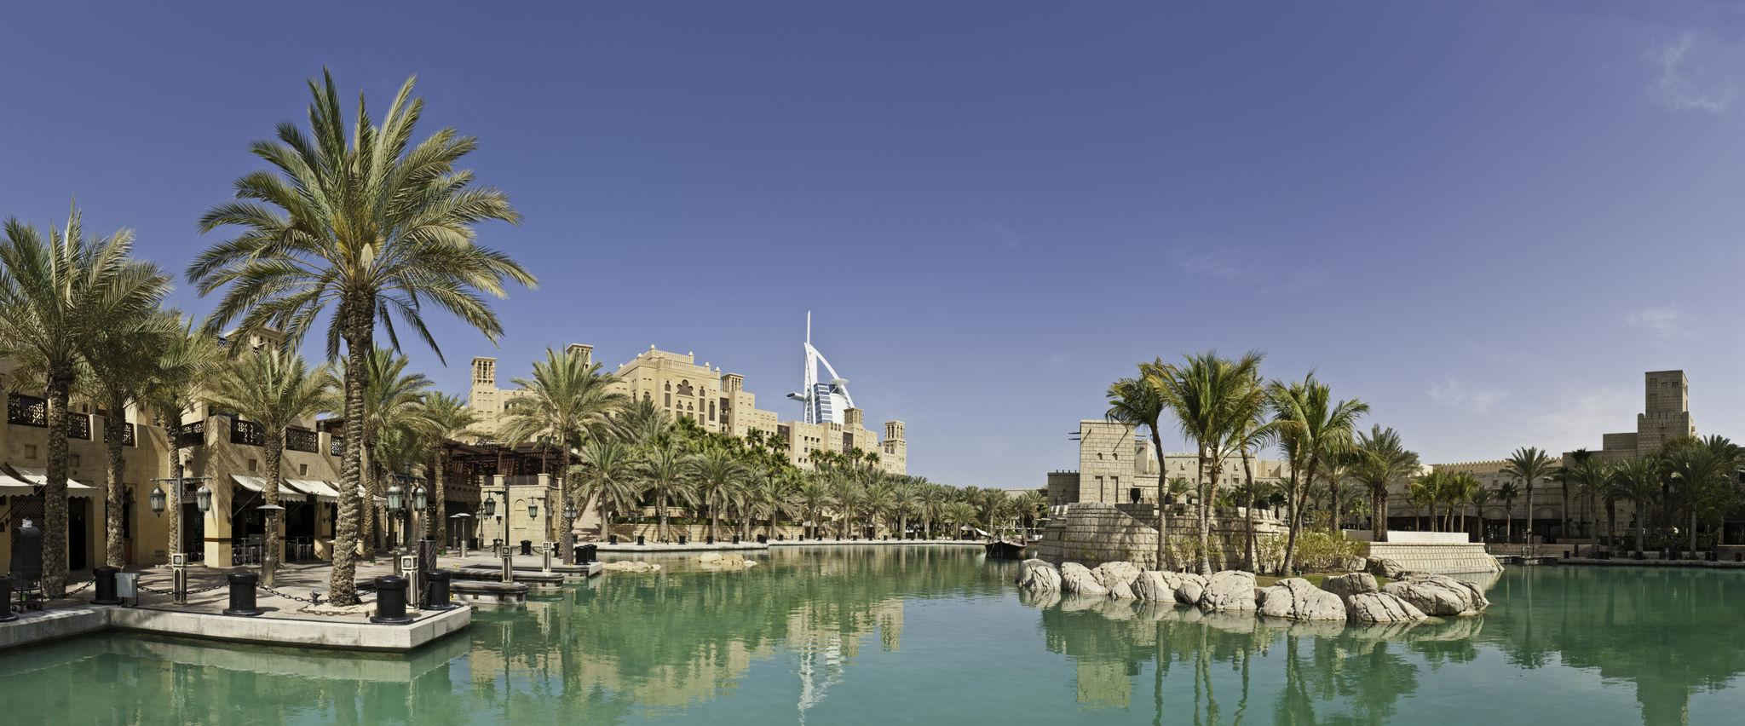
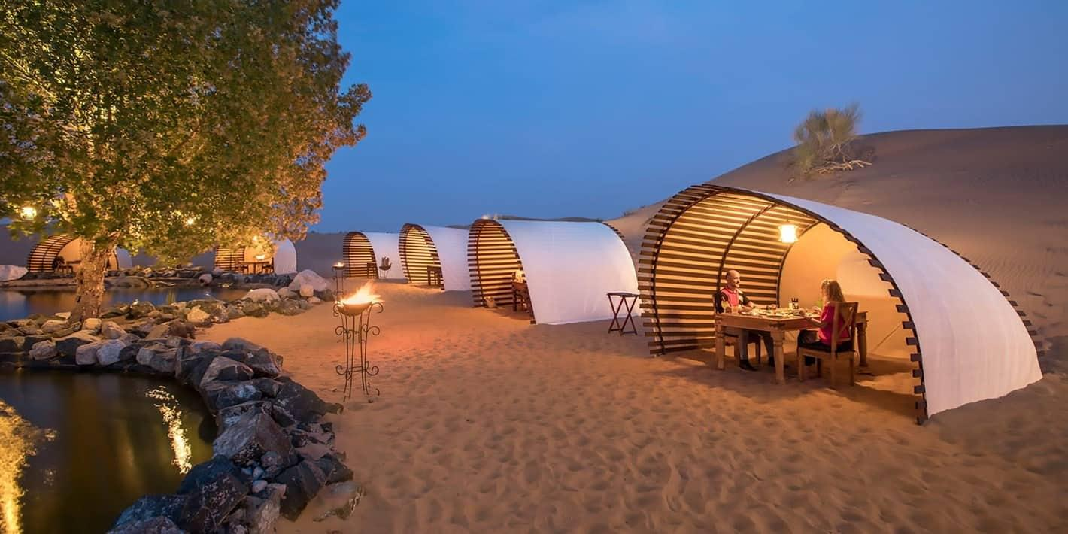

Dubai Travel Tips
- Carry light cotton clothes
- Respect UAE laws and culture
- Avoid public smoking in restricted areas
- Use Dubai Metro for easy transport
- Carry sunscreen and stay hydrated
- Book major attractions in advance

Why Choose INTRO TRAVELS INDIA for Dubai?
With INTRO TRAVELS INDIA, you get:
- Customized Dubai holiday packages
- Visa assistance
- Luxury & budget hotel options
- Honeymoon special packages
- Family & group tours
- Desert safari bookings
- Airport transfers
- Indian meal options
- Guided sightseeing tours
Dubai is a city where luxury, adventure, culture, and entertainment come together to create an unforgettable travel experience.

